**KAMPALA JUNIOR ACADEMY**

**HOLIDAY WORK SET FIVE TERM I 2020**

**PRIMARY SEVEN**

**INTEGRATED SCIENCE**

***Time allowed: 2 hours 15 minutes***

**Name: ____________________________________________________________**

**School: ___________________________________________________________**

**Read the following instructions carefully:**

**FOR EXAMINER’S USE ONLY**

1. The paper has **two** sections: **A** and **B**
2. Section **A** has 40 questions (40 marks)
3. Section **B** has 15 questions (60 marks)

**FOR EXAMINER’S USE**

**ONLY**

|  |  |  |
| --- | --- | --- |
| **Qn. No** | **MARK** | **SIGN** |
| **1 – 10** |  |  |
| **11 – 20** |  |  |
| **21 – 30** |  |  |
| **31 – 40** |  |  |
| **41 – 43** |  |  |
| **44 – 46** |  |  |
| **47 – 49** |  |  |
| **50 – 52** |  |  |
| **53 – 55** |  |  |
| **TOTAL** |  |  |

1. Answer **ALL** questions. All answers to both Sections **A**

and **B** must be written in the spaces provided.

1. All answers must be written using a blue or black ball

point pen or ink. Diagrams should be drawn in pencil.

1. Unnecessary crossing of work may lead to loss of marks.
2. Any handwriting that cannot be easily read may lead to

loss of marks.

1. Do **not** fill anything in the boxes indicated;

For Examiner’s use only.

***Turn over***

**SECTION A: 40 MARKS**

*Questions in this section carry one mark each*

1. Name the gas which plants use to make their own food. __________________________________________________________

2. State the food for male anopheles mosquitoes. __________________________________________________________

3. Which part of a living house takes out used air? __________________________________________________________

4. Mention the type of fertilization common in most fish. __________________________________________________________

5. Give one way of controlling weeds in the garden. ____________________________________________________________*The diagram below shows a balloon in air. Use it to answer the question that follows.*

6. Name the property of air that makes the above balloon fly up in air. __________________________________________________________

7. Which method of heat transfer makes us feel hot on a sunny day? __________________________________________________________

8. What is the use of a bandage kept in a First Aid box? ____________________________________________________________

9. Which component of soil is made of dead plants and animals? __________________________________________________________

10. What is the importance of a strip cup on a dairy farm? ____________________________________________________________

11. State the blood vessels that have thick walls. __________________________________________________________

12. Give any one disadvantage of heavy rain received for many days. ____________________________________________________________

13. How can coccidiosis be controlled in poultry? ____________________________________________________________

14. Give one way in which boiling water makes it safe for drinking. ____________________________________________________________

 *The diagram below is of a mushroom. Study and use it to answer questions 15 and 16*.

Q

P

15. Name the part marked **Q**. __________________________________________________________

16. State the importance of part **P** to the mushroom. ____________________________________________________________

17. Apart from keeping our feet clean, give one other reason why we should wear shoes. ____________________________________________________________

18. How do legumes keep soil fertile? ____________________________________________________________

19. State any one use of ponds to people. ____________________________________________________________

20. How are the anthers useful during pollination? ____________________________________________________________

21. State any one advantage of a waterborne toilet over a pit latrine. ____________________________________________________________

22. State any one characteristic that shows a crocodile as a reptile. ____________________________________________________________

23. Which blood cells help the body fight germs? __________________________________________________________

24. How do babies get immunity? ____________________________________________________________

25. In which units is atmospheric pressure measured? __________________________________________________________

*The diagram below shows part of the respiratory organ. Study and use it to answer questions 26 and 27.*

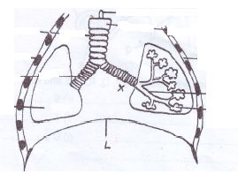

B

26. Which letter shows the part where exchange of gases takes place? __________________________________________________________

27. Give one way of keeping the organ above in good working condition. ____________________________________________________________

28. How are vultures and hyenas useful in our environment? ____________________________________________________________

29. Which body part of man will be affected due to lack of calcium in his diet? __________________________________________________________

30. Apart from diphtheria, mention any one other disease that is immunized by injection on the left upper thigh. __________________________________________________________

31. In which part of the human alimentary canal are proteins digested? __________________________________________________________

32. State any one danger of deforestation to animals. ____________________________________________________________

33. Mention the natural resource formed from animal remains buried underground long ago. _________________________________________________________

34. Give any one habit that can keep your teeth healthy. ____________________________________________________________

35. State any one way we can reduce the risks of getting malaria in our homes. ____________________________________________________________

*The diagram below shows a bee hive. Use it to answer question 36.*

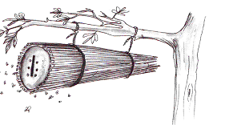

36. Name the type of bee hive shown above. __________________________________________________________

37. How is breathing in insects different from that in green plants? ____________________________________________________________

38. How does a long drum produce sound? ____________________________________________________________

39. Name the method of castration done with the use of a burdizzo. __________________________________________________________

40. What happens to the pitch of sound of a guitar when the string is tightened? ____________________________________________________________

**SECTION B: 60 MARKS**

*(Questions in this section carry four marks each)*

41.a) Name the disease spread by each of the organisms below:

(i) dogs ______________________________________________________

(ii) water snails ________________________________________________

(b) Give any two ways we can prevent dogs from spreading the disease named above.

(i) __________________________________________________________

(ii) __________________________________________________________

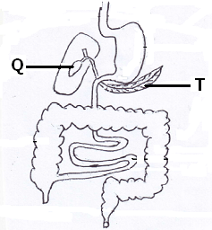42. *The diagram below is of a human digestive system. Study and use it to answer the questions that follow.*

(a) Name the parts marked **Q** and **T**.

(i) **Q** ________________________________________________________

(ii) **T** ________________________________________________________

(b) Which class of food is first digested in part **Q**? __________________________________________________________

(c) Name the digestive juice produced by organ **T**. __________________________________________________________

43. *In the table below, part A shows plants and part B shows sentences describing each plant.*

**A** **B**

Beans produce pollen and ovules in cones

Liverworts bears seeds with one cotyledon

Cedars have a network leaf venation

Maize are spore bearing plants

Beans ___________________________________________

Liverworts ___________________________________________

Cedars ___________________________________________

Maize ___________________________________________

44.a) Name any two types of breeds of cattle kept in Uganda.

(i) __________________________________________________________

(ii) __________________________________________________________

(b) Give the main product from a cattle ranch. __________________________________________________________

(c) State one reason why government sometimes restricts the movement of animals in a given region. ________________________________________________________________________________________________________________________

45.a) To which group of juicy fruits do mangoes and coconuts belong? __________________________________________________________

(b) How is the internal structure of a mango similar to that of a coconut? ____________________________________________________________

(c) Give two other fruits which have a structure similar to that of mangoes and coconuts.

(i) __________________________________________________________

(ii) __________________________________________________________

46a) Give one way in which man acts as an agent of soil erosion. ________________________________________________________________________________________________________________________

(b) How do cattle contribute to soil erosion? ________________________________________________________________________________________________________________________

(c) State any two ways of conserving land.

(i) __________________________________________________________

(ii) __________________________________________________________

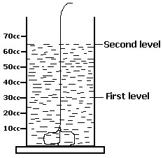47. *The diagram below shows a method of finding volume. Use it to answer questions that follow*.

(a) Name the method shown in the experiment above. __________________________________________________________

(b) If the mass of the stone is 45g, what is the density of the stone? (2marks)

(c) Name any one instrument used to measure mass of objects. __________________________________________________________

48a) Apart from man and animals, mention two natural sources of sound.

(i) __________________________________________________________

(ii) __________________________________________________________

(b) State one reason why sound does not travel through vacuum. ____________________________________________________________

(c) Mention any one reason why animals make sound. ____________________________________________________________

49a) What is Zero-grazing? ________________________________________________________________________________________________________________________

(b) Give one reason why zero grazing is suitable in urban areas. ____________________________________________________________

(c) State any two advantages of zero-grazing.

(i) __________________________________________________________

(ii) __________________________________________________________

50a) Mention any two permanent methods of birth control in males and females.

(i) males _____________________________________________________

(ii) females ___________________________________________________

(b) State one benefit of good child spacing to the mother and her children.

(i) to the mother ____________________________________________________________

(ii) to the children ____________________________________________________________

*The diagram below shows one of the methods of preparing alcohol. Study and use it to answer question 51.*

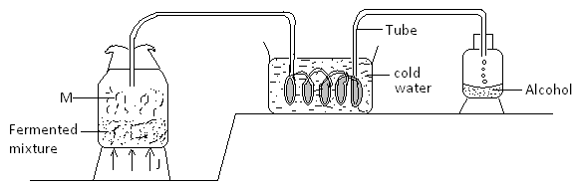

51a) Name the method shown above in the diagram. _________________________________________________________

(b) What do the arrows labeled J represent? __________________________________________________________

(c) Why is the coiled part of the tube dipped in cold water? ________________________________________________________________________________________________________________________

(d) Name the process which leads to formation of part M. __________________________________________________________

52.a) What is seed dispersal? ________________________________________________________________________________________________________________________

(b) Name two agents of seed dispersal.

(i) __________________________________________________________

(ii) __________________________________________________________

(c) State any one advantage of seed dispersal. ____________________________________________________________

53a) Give the difference between scalds and burns. ________________________________________________________________________________________________________________________

(b) Mention any two causes of scalds at home.

(i) __________________________________________________________

(ii) __________________________________________________________

(c) State the First Aid recommended for people affected by scalds and burns. ____________________________________________________________

54a) *Below is an illustration of a process which occurs in plants. Study and use it to answer the questions that follow.*

Carbon dioxide + water starch + oxygen

(a) Name the process shown above.

__________________________________________________________

(b) Identify the two conditions needed for the above process to occur.

(i) __________________________________________________________

(ii) __________________________________________________________

(c) Name the by-product of the above process. __________________________________________________________

55. *The diagram below shows part of an intestinal worm. Study and use it to answer questions that follow.*

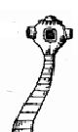 Y Z

X

(a) Write the general name of part marked Z. ________________________

(b) Name the part marked X. ____________________________________

(c) State the use of part Y to the worm. ____________________________________________________________

(d) State any one way the above worm enters the human body. __________________________________________________________

**END**